Deploying SPSS stream for openscale monitoring.

1. Create SPSS stream within Watson Studio Cloud. Make sure you have scoring branch defined which doesn’t contain your target field (i.e. CHURN).

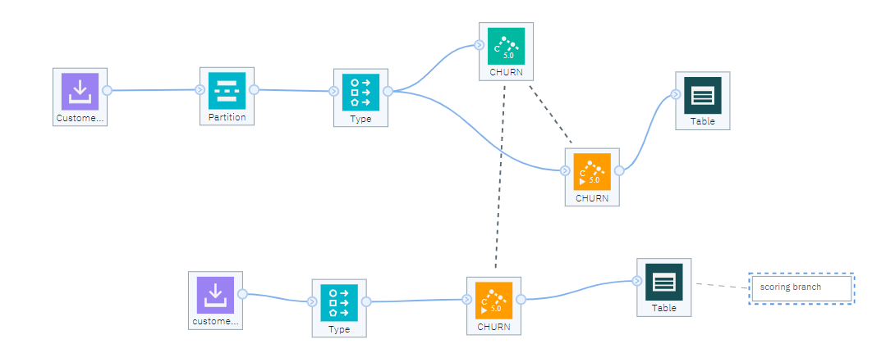

The reason for it is that when setting up openscale in UI, it compares the fields coming into the model in the scoring branch and compares to all the fields that model was built on and presents the difference as selection for prediction field. If fields are exactly the same on modeling and scoring branch , openscale will not present any fields for selection.

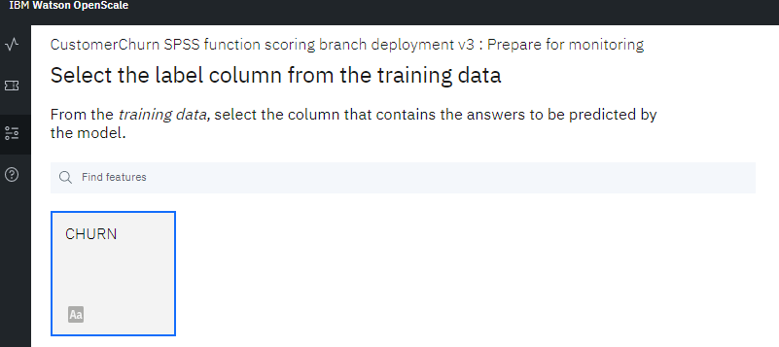

1. Save branch as a model

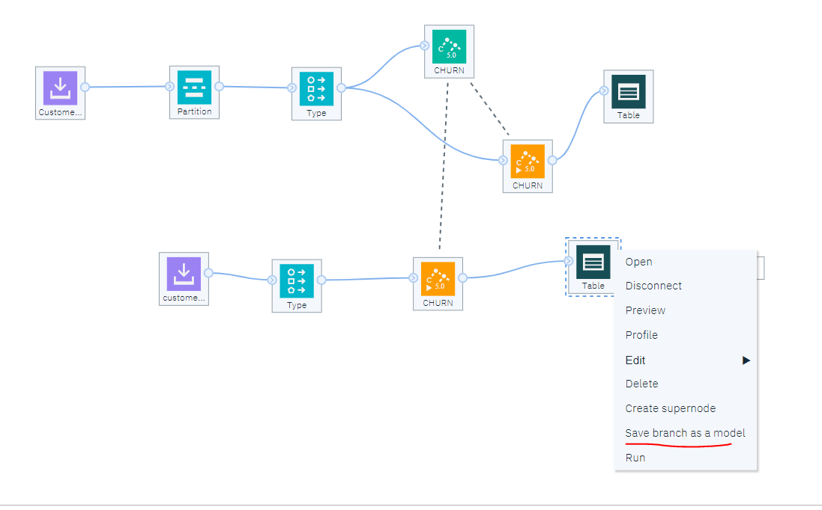

1. Deploy save model as a web service

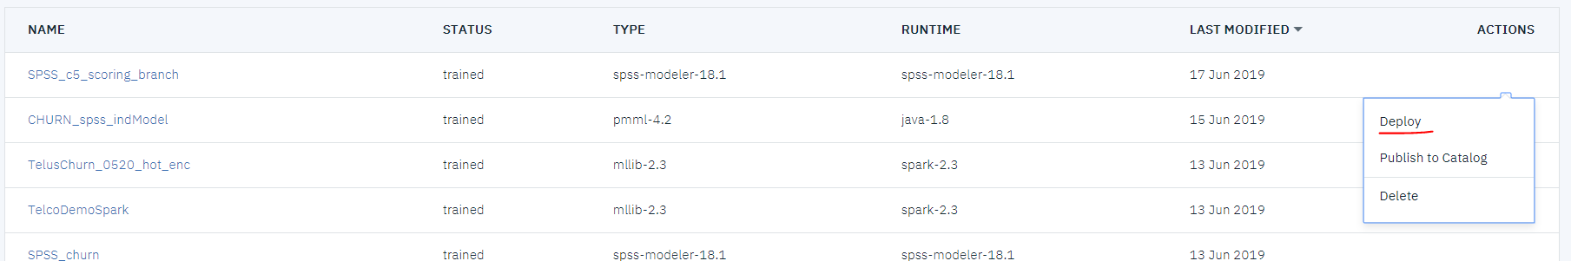

1. Score deployed SPSS model in UI to make sure it is working

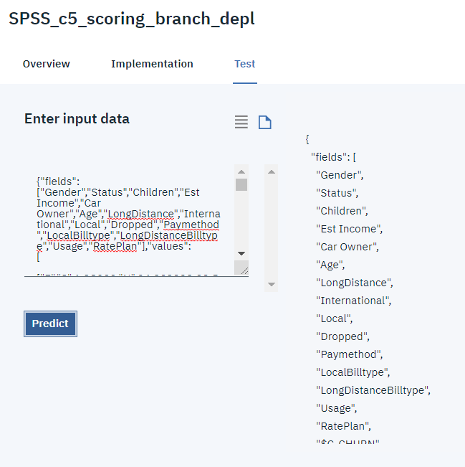

1. Next step is to create python function that will add new fields to the payload:

'probability', 'prediction', 'predictedLabel'

1. See notebook for function definition. Notebook creates the function, saves it and deploys it to WML
2. After that, you can go into your deployments and test the function

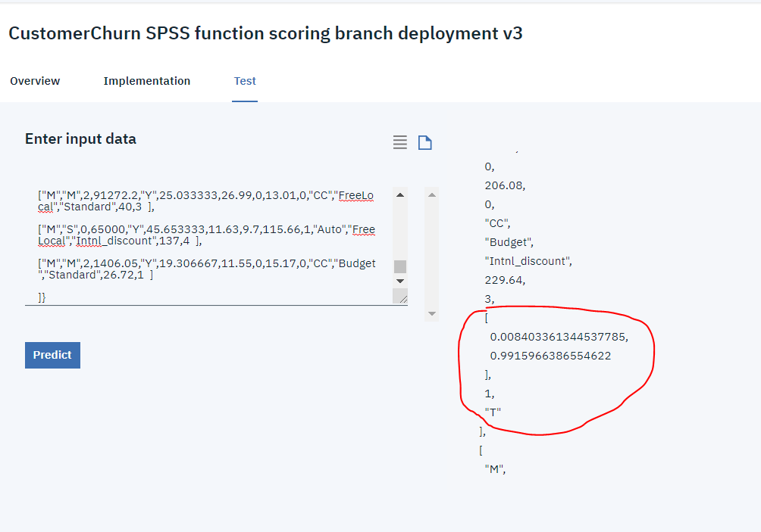

1. Next step is to set up openscale as usual from UI